Python In-Class Assignment

Part A - Data Cleaning

DATA CLEANING REPORT
1. Duplicate transactions removed: 85
2. Invalid quantity records removed: 207
3. Records remaining after cleaning: 2,878
4. Total revenue: $917,595.65
5. Total gross profit: $301,221.01

Observations: Despite the business’ large revenue, a large amount of this money is lost to product costs.

Part B - Data Analysis & Visualization

Revenue & Profit by Product Category

Observations: When looking at each product category, electronics is the top category with the strongest revenue and gross profit. On the other hand, other categories, such as groceries and food take up operational resources but generate the lowest revenue and profit margins. When comparing the revenue and profit of electronics, the gross profit shows that the difference between electronics and other product categories is smaller in terms of profit. It is evident that the groceries and food bring little benefit to the business despite requiring labour and inventory.
Recommendation: ShopSmart should look into investigating why groceries are underperforming compared to electronics, and consider reducing grocery costs to focus more on investing labour and cost into more profitable categories such as electronics, sports, home and apparel.
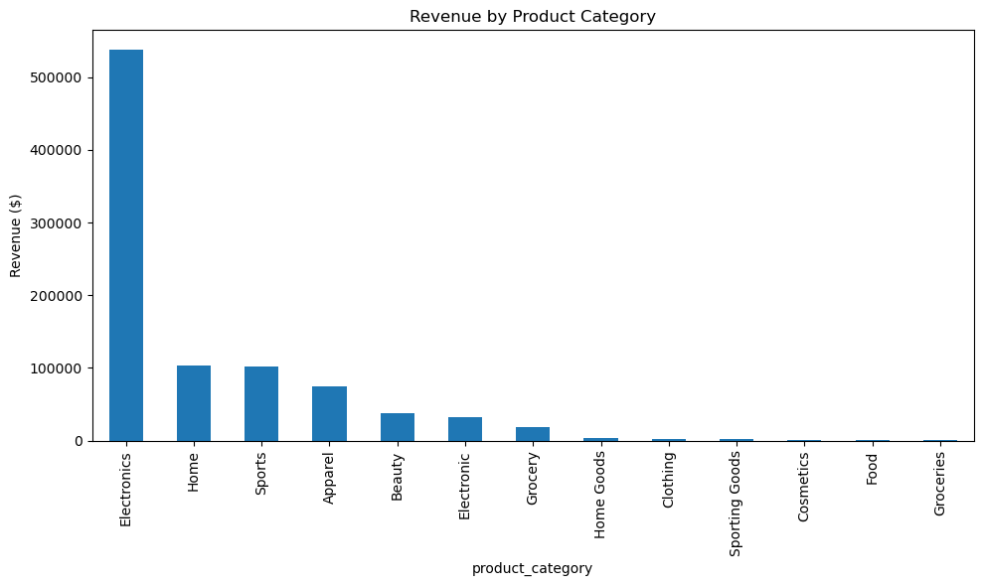


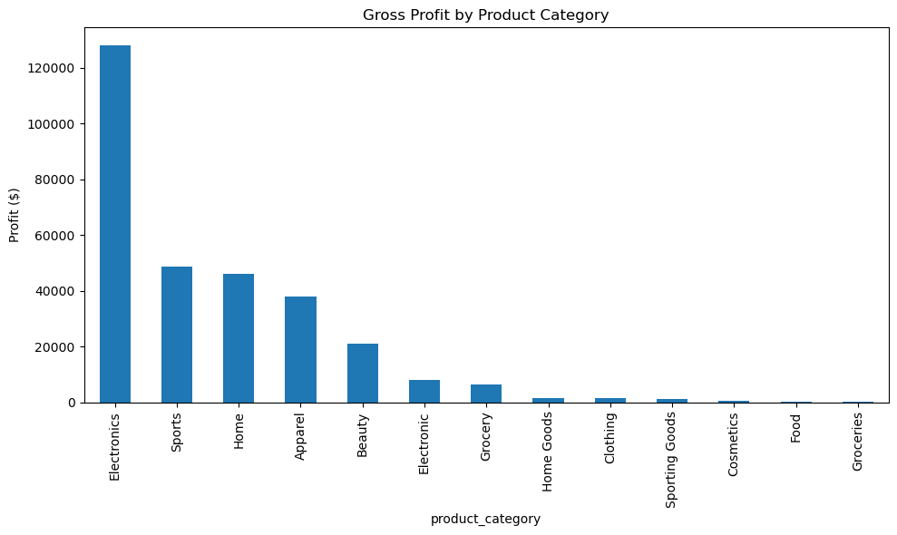
Profit & Labour Efficiency by Region
Observations: When comparing gross profit across regions, the South brings in the most profit, while the North is significantly less profitable compared to the other regions. This suggests differences in operating efficiency, inventory management, staffing levels, or local market conditions. Given that the labour efficiency in each of these regions is similar, it is possible that other factors, such as higher supplier costs, high shipping costs, product availability or higher sales volume in the South region could explain these differences between the two regions.
Recommendations: ShopSmart should investigate reasons why the North could be lagging behind in profit compared to other regions. If less profitable product categories (i.e. groceries) are sold in the North, the company should consider shifting marketing budgets to electronics. The company could also verify if Northern suppliers are overcharging for inventory. Additionally, sharing best practices from higher-performing stores may help improve consistency and increase profitability across the organization.

